There are 8 mat lab file (.m) in this project.

1. generate_zip_code.m: This file is used for generating zip code for each ID given the enplanement passengers in each zip code area.
2. GoogleMapAPI.m: This file is used for generating travel distance for each ID given zip code, the travel distance is calculated by Google map recommended route.
3. Modes_distribution_by_percentile: This file is used for generating travel modes for each ID given the percentage of each travel modes. This file is a function file, in which the variables are ID and travel modes percentage.
4. parking_cost_calculation.m: This file is used for calculate parking cost for each ID based on current TPA parking charges. Information is given by simulation_all.
5. Main_iteration.m: This file is the main file for simulation which have 7 steps. The outcomes of this 7 steps is corresponded to columns in simulation_all. This file is a function, independent variables are:

Parking_over_parking_curbside: current parking percentage/parking+curbside

Percent_parking_and_curbside: current percentage of parking+curbside

AV_adoption_rate: 0%, 5%...100%, total 20

Id: the id_th adoption rate

Dependent variables are:

Parking_over_parking_curbside_new

Parking_revenue_out

1. Main_method1_constant_parking_percentile.m: This file is the same as main_iteration, only difference is the percentage of parking and curbside is the current value, and no iteration.
2. Main_method2_ iterative_parking_percentile: In this file, given the initial percentage of parking/parking+curbside which is current value, and calculate new parking/parking+curbside due to AV emerging with a certain adoption rate, and iterate within the same adoption rate
3. Main_method3_adaptive_parking_percentile.m: In this file, given the initial percentage of parking/parking+curbside, assume when AV adoption rate is 5%, the parking percentage is current value, and then calculate the new percentage of parking due to emerging of AV, then use this new percentile to simulate the situation when adoption rate is 10%, so on and force.

**simulation_all**

1: IDs, 2: Zip codes (from generate_zip_code.m), 3: travel modes (from function Modes_distribution_by_percentile.m) 4. parking modes (from function Modes_distribution_by_percentile.m) 5. parking duration 6.distance (from GoogleMapAPI.m) 7. private car that has AV or not

Step 1: generating IDs

Enplanements forcast *95% (only 5% transfer passenger) ---3 scenarios

Step 2: Generating zip codes

Primary draw area: depend on population density

Secondary draw are: depend on population density * distance probability (P (min-distance) = 1 and P (max-distance) = 0)

Distance of each zip code – Using Googlemap API recommend route “GoogleMapAPI.m”

Step 3: Generating travel modes

1. Private parking, 2. Curbside, 3. Rental car, 4. Commercial vehicle

Step 4: Generating parking modes:

1. short-term hourly parking, 2. short-term daily parking 3. long-term parking, 4. economic parking, 0. non-private parking

Step 5: Parking time

1. Short term hourly

2. Short term daily

3. Long term

4. Economic

Step 6: Private car that is AV or not

Step 7: Calculate parking cost and round trip fuel cost using data in simulation_all

And making choice based on these two cost

**cost_parking_fuel**

1. ID, 2. parking cost, 3. round-trip fuel cost of AV 4. choice (0 parking, 1 AV), 5. lost parking fee

Main iteration

Parking_over_parking_curbside

Results of 3 methods:

1. Constant parking percentage:

Parking percentile is current value which is 19.6%

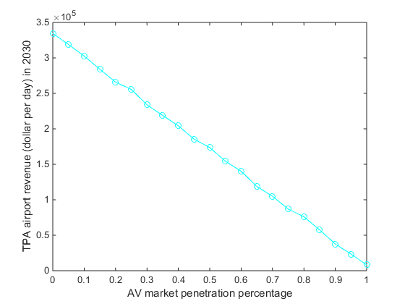

1. Iterative parking percentage:

Iteration within same AV adoption rate

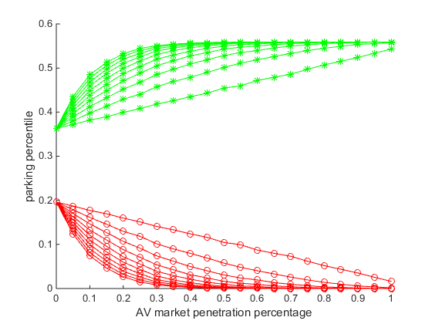

1. Adaptive parking percentage:

Iteration with 5% increase of AV adoption rate

